**Data Preparation**

Analysis of combined_data.csv

Sample Selection

|  |  |
| --- | --- |
| **Item** | **Amount** |
| # of Samples | *4619* |
| # of Samples with Purchases | *1411* |

Attribute Creation

A new categorical attribute was created to enable analysis of players as broken into 2 categories (HighRollers and PennyPinchers). A screenshot of the attribute follows:

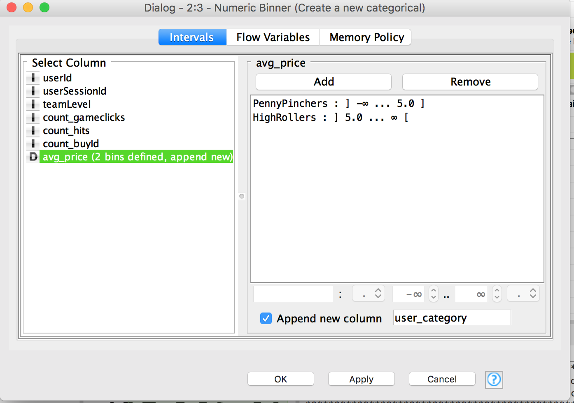

*A new categorical attribute, named “user_category”, is created by the Numeric Binner node. As presented in the instruction, we need to define two categories for price which we will use to distinguish between HighRollers(buyers of items that cost more than $5.00) and PennyPinchers (buyers of items that cost $5.00 or less), so as we see in the screenshot above, the user who costs $5.00 or less is defined as “PennyPinchers”, the user who costs more than $5.00 is defined as “HighRollers”.*

The creation of this new categorical attribute was necessary because *it can facilitate the classification of users and contribute to the following steps.*

Attribute Selection

The following attributes were filtered from the dataset for the following reasons:

|  |  |
| --- | --- |
| **Attribute** | **Rationale for Filtering** |
| *userId* | *Since the objective is to predict which user is likely to purchase big-ticket items, and the attribute “userId” has no effect on it, so it’s removed.* |
| *userSessionId* | *Since the objective is to predict which user is likely to purchase big-ticket items, and the attribute “userSessionId” has no effect on it, so it’s removed.* |
| *avg_price* | *Since a new attribute “user_category” has been created, which was generated from the attribute “avg_price”, so we can remove it.* |
| *userId* | *Since the objective is to predict which user is likely to purchase big-ticket items, and the attribute “userId” has no effect on it, so it’s removed.* |